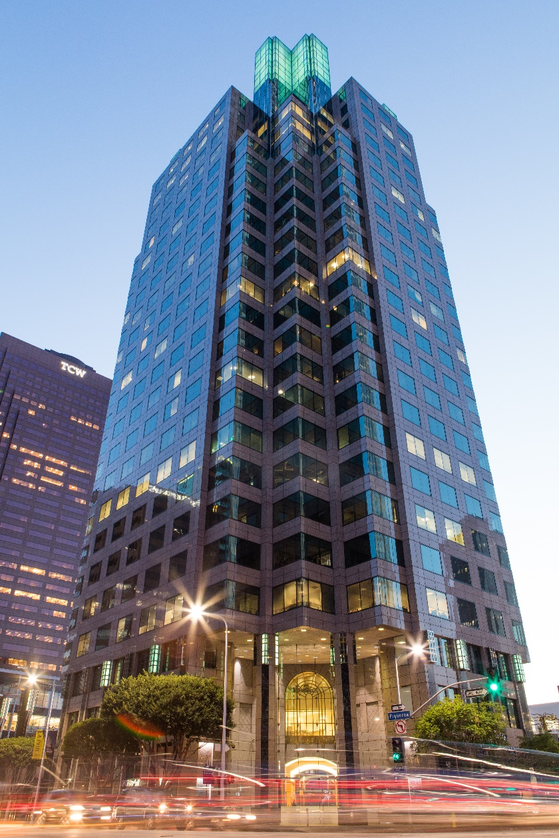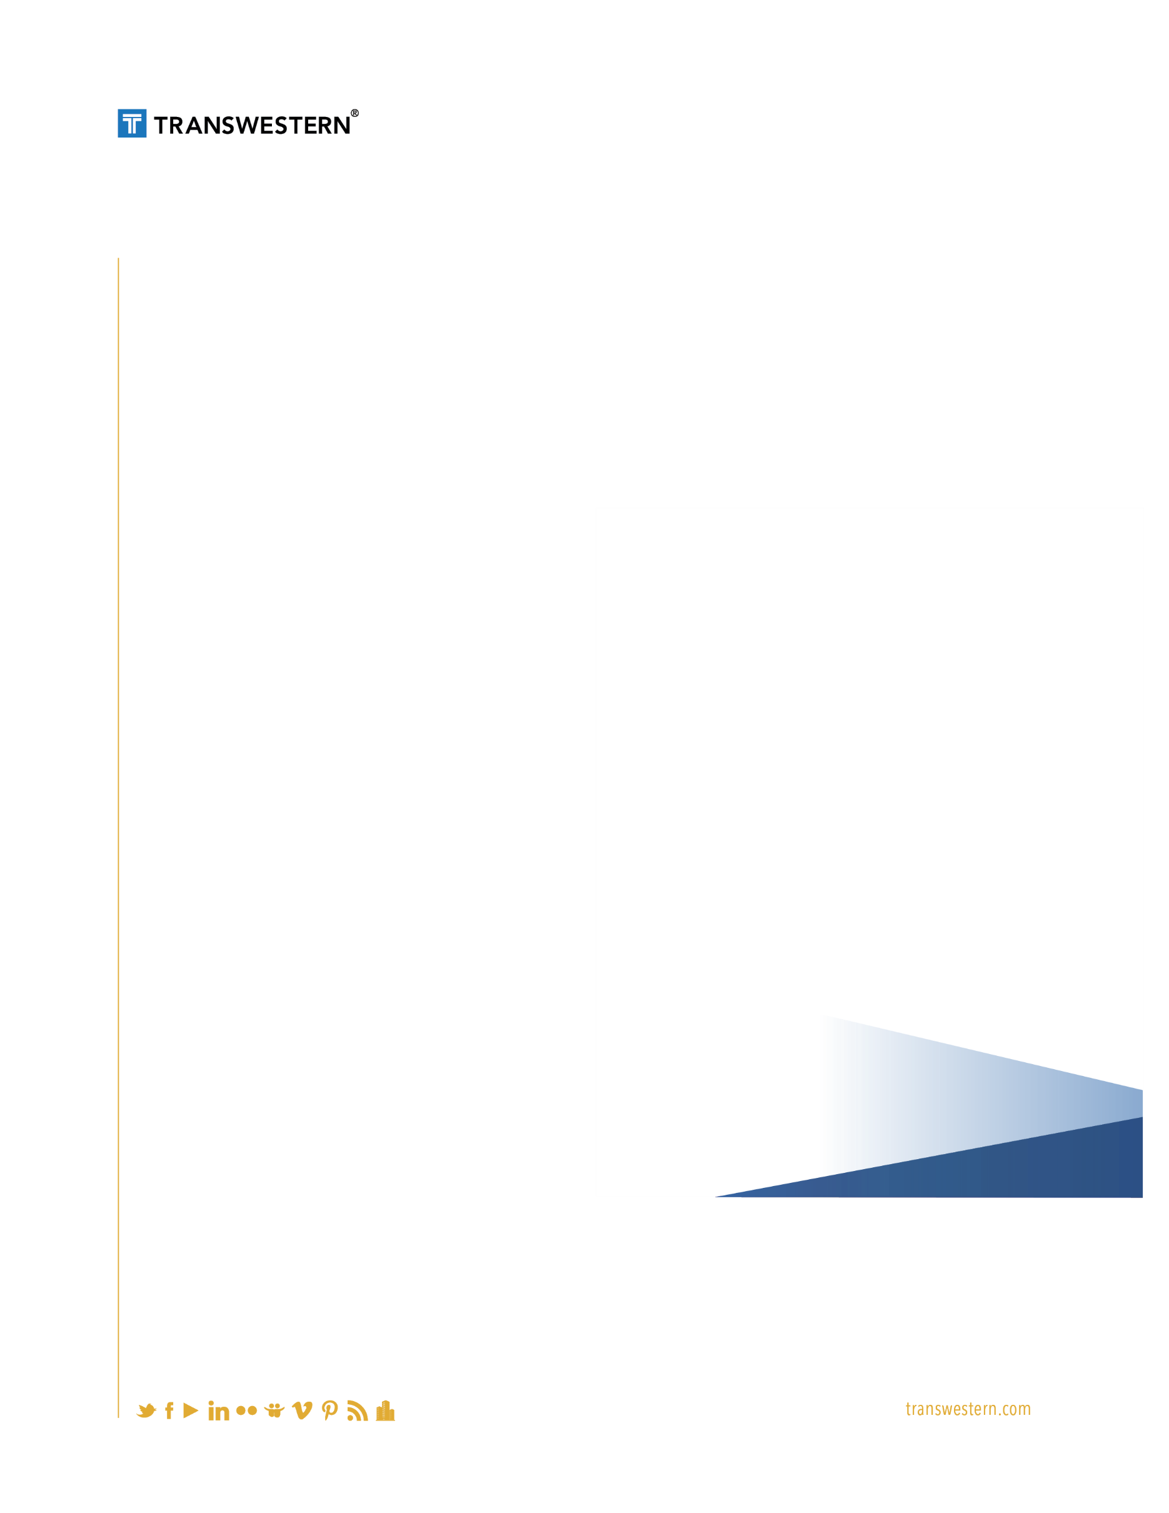

OPPORTUNITY

Cornerstone acquired 801 S. Figueroa Street in 2014 and hired Transwestern to address maintenance issues, outdated common areas and tenant concerns.

SOLUTION

* Created a deferred maintenance list immediately and began addressing critical issues with building systems to correct years of deferred maintenance and uncompleted repairs
* Hand-picked onsite staff to personify the Transwestern Experience, becoming a visible and pro-active (rather than reactive) presence to the tenant base

Results

Transwestern’s three-pronged approach to asset services improved key metrics in three crucial areas of building management: systems and operations, physical appearance, and tenant satisfaction. Initial management efforts not only helped reduce operating expenses for the client, but also increased tenant satisfaction and curb appeal to visitors and potential tenants. Under Transwestern’s management, 801 South Figueroa Street is once again a trophy asset in the most competitive submarket in Downtown Los Angeles.

Extraordinary Delivered

801 s. figueroa street

Los Angeles, California

Asset Services